**Title**

Full name of the first author (without mentioning the prefix such as doctor, sir, ...)

Location of the first author,

E-mail:

**Hamed Nikpey 1**

Education Administry of Mahmoudabad-Mazandaran

Hamednikpey@yahoo.com

Attention:

- At the top, delete the words "Article Title" and write the selected title of your article instead.

- In the top, delete the "full name of the first author (without mentioning the prefix such as doctor, sir, ...)" and write your name.

- In the top, delete the "place of activity of the author" and write the name of your place of activity (university, etc.).

- At the top, delete E-mail: and write your email.

- Fill in the bottom (footnote).

- Write the names of the authors on the even pages and in the upper part (footer) of the even pages.

**Abstract:**

(Writing an article for publication in the conference must be in accordance with the rules and format contained in this article format. If your article does not comply with the rules and format, you need to correct it. The abstract section includes a brief description of the content of the article without reference to sources. The abstract should provide a concise and useful description of the article and should consist of a minimum of 80 to a maximum of 200 words. The distance of the text from the right and left edges of the page should be 3.5 cm.)

**Keywords:**

(Three to five keywords or phrases can be entered in this section. Place commas between words and phrases.)

1. **Introduction**

This section contains the necessary instructions to prepare the paper for publication in the Seventh National Conference on New Approaches to Education and Research. You can easily enter your text in this template to ensure that the article format is followed. All articles must be written in Microsoft Word 2007 software or higher and submitted in * .docx format.

The article should be considered as a text

Write a line spacing between the lines. Adjust the text border from the edges of the page as follows:

• Distance from above = 3 cm

• Distance from the bottom = 3 cm

• Distance from left = distance from right = 2.5 cm

2. Number of article pages

The number of pages of the article should not exceed ten pages. Adjust the print-ready paper to 210mm (8.27 inches) wide and 297mm (11.69 inches) wide. Please do not change the paper size and writing style defined.

3. Mathematical expressions

Mathematical expressions should be written in two-column tables without frames, as in the example below. (Using software mathematical expressions) 

4. Tables and figures

All tables and figures should be in the center of the page and in sequence in the text. The title of the table should be written at the top of the table in the right corner and the title of the figure should be written at the bottom and in the middle. A blank row should be considered before and after each table and figure. Table 1 contains the necessary information for writing an article.

**Table1: Information for writing Article**

|  |  |  |  |
| --- | --- | --- | --- |
| **kind** | **Font** | **Pen** | **Subject** |
| Bold | 14 | B Titr | Title |
| Bold | 14 | B Nazanin | Name and Family |
| Regular | 12 | B Nazanin | brief address of writers |
| کج | 11 | Times New Roman | email |
| Bold | 14 | B Zar | Section Title |
| Bold | 12 | B Zar | Sub-section Title |
| Regular | 12 | B Lotus | Abstract text |
| Regular | 12 | B Lotus | KeyWords |
| Regular | 12 | B Lotus | Content of Article |
| Regular | 10 | B Lotus | Footage |
| Bold | 10 | B Lotus | Tables |
| Regular | 10 | B Lotus | Content of Tables |
| Regular | 12 | B Lotus | Farsi References |
| Regular | 11 | Times New Roman | English References |

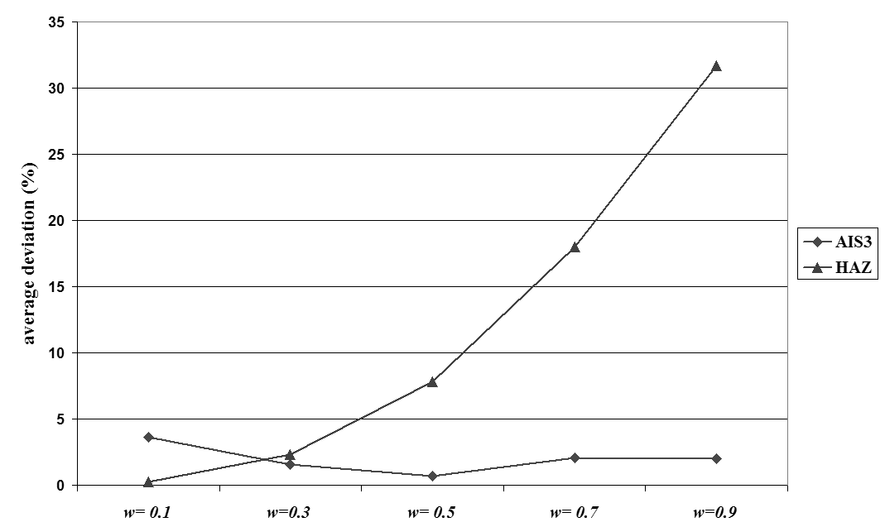

**1. figure**

5. **Conclusion**

In the conclusion section, the main concepts and achievements of the article are mentioned, but the text of the abstract section should not be repeated in this section. Therefore, the conclusion section can include pointing out the importance of the topic under discussion, future suggestions, and appendices.

6. **Acknowledgement**

The acknowledgement section is optional. Acknowledgments and resources should not be numbered.

7. **References**

Persian sources should be written in ordinary Lotus B and English sources should be written in Timesmanian. Please use bold, crooked and regular font styles for different backgrounds such as the following. Number the resources in sequence in the brackets

(For example [Akbari, 1396: p. 32]).

Please refer to a specific source only in this way, such as [Ahmadlou, 1398: p. 45] and avoid quoting phrases such as "source [3]".

To refer to multiple sources, use parentheses and put the number of each source in a separate bracket, for example:

([Ahmadloo, 1398: p. 45], [Nikey, 1399: p. 232]).

How to refer to different sources is as follows:

• Reference to the book in [Akbari,: 1396, p. 137],

• Reference to the paper presented at the conference in [Ahmadlou, 1398: p. 45],

• Reference to an article published in magazines such as [Nikpey, 1399: p. 232],

• Reference to doctoral dissertation in [Mohammadi, 1395: p. 83],

English Reference [Nikpey, 2013: p. 38]

**Persian References:**

[1]. اکبری، عسگر. ادبیات کودکان و نوجوانان: اطلاعات و ارتباطات. اراک: دانشگاه آزاد اسلامی، 1396.

[2]. احمدلو، معصومه. آسیب­شناسی پژوهش و تحلیل موانع پژوهشی از دیدگاه اعضای هیأت علمی دانشگاه­ها. هفتمین همایش ملی پژوهش­های مدیریت و علوم انسانی در ایران. دانشگاه تهران، 27 شهریور، 1398.

[3]. نیک­پی، حامد و رفیع، حسین. نقش آلمان در آیندۀ همکاری های ایران و اتحادیۀ اروپا. فصلنامه پژوهشهای روابط بین الملل، 1399، 9(34)، ٣١٤-٢٨٥.

[4]. محمدی، پرهام. پیش‌‌بینی وابستگی به فضای مجازی براساس بهزیستی روان‌‌شناختی و احساس تنهایی در دبیران (پایان­نامه کارشناسی ارشد). تهران: دانشگاه علم و صنعت، دانشکده فنی و مهندسی، 1395.

**English References:**

[5] Nikpey H and Medghalchi A. Characterizing injective operator spaces for which I(V )= B(H). Debrecen, 34(2); 31-47; 2013.

[6] Nosoohi A, Shahandeh A. Contract design for increasing supplier’s capacity in a two stage supply chain, with stochastic demand. Proceeding of IEEE International Conference on Logistics Informatics and Supply Chain Management. 2514-2518; 2009.

[7] Kianfar K, Fatemi G and Karimi B. [New dispatching rules to minimize rejection and tardiness costs in a dynamic flexible flow shop](http://www.springerlink.com/content/enn6k62632100406/?p=4a12bfd77cbf47289c8523dccb76bce5&pi=0). International Journal of Advanced Manufacturing Technology. 45(8), 759-771; 2009.

[8] Akbari A. The Impact of Foreign Direct Investment on Health in Developing Countries [dissertation].Arak: Islamic Azad University; 2020.